NAME: VENKATRAMAMOORTHY.G
- Write a function that accepts a callback.
CODE:
function add(a,b,callback){
return callback(a+b);
}
function mul(a){
return a*5;
}
let result=add(1,2,mul);
console.log(result);
OUTPUT:
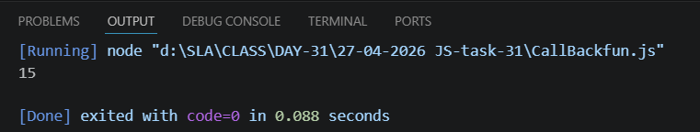
- Create a promise that resolves or rejects.
CODE:
function add(a,b,bol){
return new Promise((resolve,reject)=>{
if(bol){
resolve("Promise is accepted "+ (a+b));
}
else{
reject("it is rejected");
}
})
}
add(1,2,true)
.then((result)=>{
console.log(result)
})
OUTPUT:
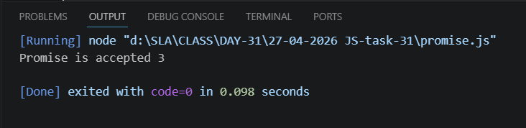
- Handle promise using then and catch.
CODE:
function check(a){
return new Promise((resolve,reject)=>{
if(a>0){
resolve("it is resolve " + a);
}
else{
reject("it is a rejection")
}
})
}
check(-2).then((result)=>{
console.log(result);
console.log('...')
})
.catch((error)=>{
console.error(error);
})
OUTPUT:
